Users Manual

# Necessary actions to run program

1. Consult the file Prolog/server.pl on sicstus and run the command “server.”
2. Use your favourite option to run the WebCGF server (example: web server for chrome extension) on the Files folder.
3. Open the WebCGF server on your browser
4. Enjoy the game!

# Instructions of the game

The goal is to be the first player to pose the fourth different forms of a line, a column or a square zone.

Each turn the players will put one of their pieces on the boardgame. It's forbidden to put a shape in a line, a column or an area on which this same form has already been posed by the opponent. We can only double a shape if we have played the previous one ourselves. The first player who places the fourth different form in a row, column or zone wins the game immediately, no matter who owns the other pieces of that winning move.

# User Instructions

To play the game, simply select a piece with a click of the mouse, and then either change the selected piece or select one of the highlighted tiles to play that piece with another click.

Using the interface you can change the bot intelligence (if Intelligent AI selected the bot will be intelligent), the game mode, the scene file, turn on and off lights and change the camera (the first camera is locked and changes when the turn changes, the others aren’t). You can also undo the last move, restart the game or play a movie of the entire game.

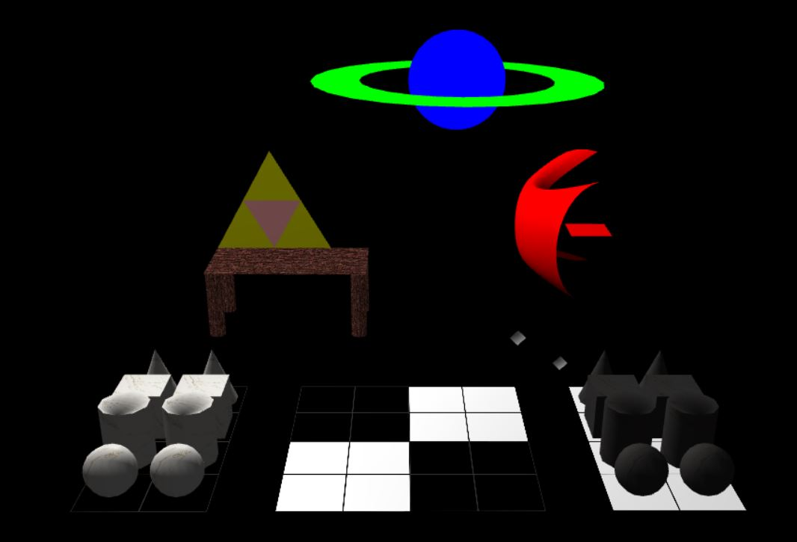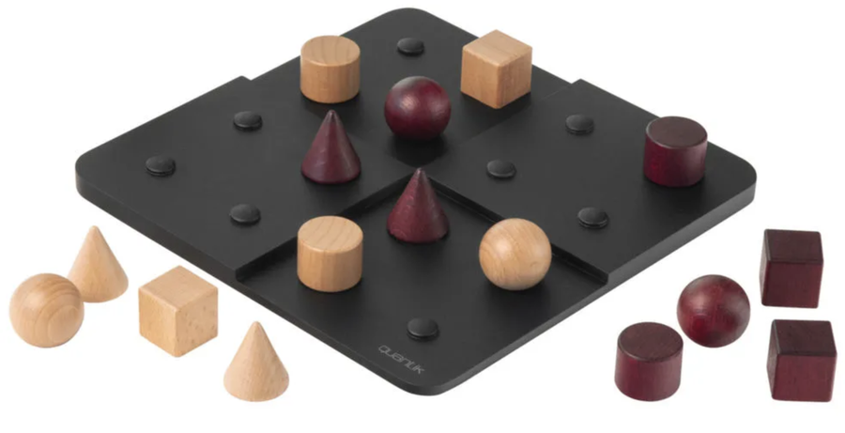Original game

My version